

JWH

logo

** refuse & Recycling News**

***reduce waste and increase recycling!***



Services for the Los Angeles County Unincorporated Areas



**Joe Waste Hauler**

Insert own photo relating to the article

**Mandatory Commercial Recycling**

**R**ecent state legislation will make recycling mandatory for all applicable businesses and apartment buildings located within the County of Los Angeles unincorporated areas beginning July 1, 2012. All businesses that produce more than 4 cubic yards or more of trash per week and multi-family properties of 5 units or more (such as apartment buildings) will be required to recycle through one of the following: subscribe to a service that collects recyclables separately, send materials to a mixed waste processing facility that diverts recyclables, or self haul recyclables. Fortunately, for businesses and apartments located in the County of Los Angeles unincorporated areas, FREE recycling service is available. If you are a property or business manager and would like to sign up for recycling service, contact (insert Hauler name and number).

Subscribing to a recycling service helps you comply with the new regulation and can also save you money. Be sure that you are recycling everything you can! To learn more about the new legislation, visit [www.calrecycle.ca.gov/Climate/Recycling](http://www.calrecycle.ca.gov/Climate/Recycling).

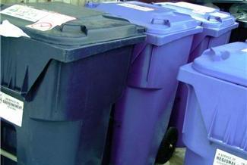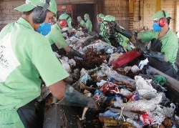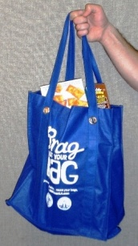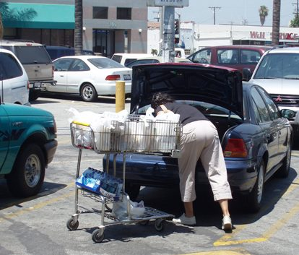

**Insert tip or article**

**Tip of**

**The Month**

Insert photo caption

Curbside bins

Sorting recyclables

**Article #3**

**S**ample sample sample sample sample sample sample sample sample sample sample sample sample sample sample sample sample sample sample sample sample sample sample sample sample sample sample sample sample sample sample sample sample sample sample sample sample sample sample sample sample sample sample.

Sample sample sample sample sample sample sample sample sample sample sample sample sample sample sample sample sample sample sample sample sample sample sample sample

Sample sample sample sample sample sample sample sample sample sample sample sample sample sample sample sample sample sample sample.

Sample sample sample sample sample sample sample sample sample sample sample sample sample sample sample sample sample sample sample Sample sample sample sample sample sample sample sample sample sample sample sample sample sample sample.

**Article #2**

(left) Reusable bags handed out to shoppers.

(right) Shopper with several plastic bags.

**S**ample sample sample sample sample sample sample sample sample sample sample sample sample sample sample sample sample sample sample sample sample sample sample sample sample sample sample sample sample sample sample sample sample sample sample sample sample sample sample sample sample sample sample.

Sample sample sample sample sample sample sample sample sample sample sample sample sample sample sample sample sample sample sample sample sample sample sample sample

Sample sample sample sample sample sample sample sample sample sample sample sample sample sample sample sample sample sample sample.